# ****Phase 8: Data Management & Deployment****

**Prepared by:** Kakumani Naga Jahnavi

## ****Overview****

Phase 8 focuses on effective data management and structured deployment within the Smart Healthcare CRM. The primary goal of this phase is to ensure data integrity, streamline bulk operations, prevent duplicates, maintain regular backups, and enable smooth deployment of workflows, flows, and custom development. This phase combines Salesforce declarative tools and developer-friendly deployment techniques to maintain a robust, secure, and scalable system.

## ****Data Import Wizard****

The Salesforce **Data Import Wizard** is used to import patient and doctor records into the CRM efficiently. Administrators can upload CSV files, map fields to Salesforce objects, and process imports without requiring programming knowledge. This tool ensures that new data is accurately added, consistent with existing records, and properly formatted.

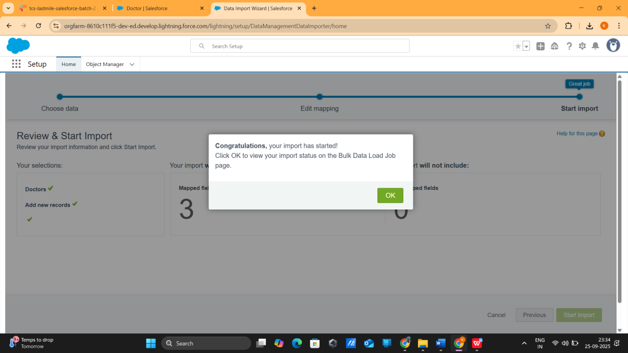

## ****Data Loader for Bulk Appointment Uploads****

For handling large volumes of data, such as bulk appointment uploads, Salesforce **Data Loader** is utilized. This tool allows administrators to insert, update, or upsert thousands of records from CSV files. It provides detailed success and error logs, which ensure transparency and allow corrections when necessary. Data Loader is ideal for large-scale data operations that exceed the capacity of the Data Import Wizard.

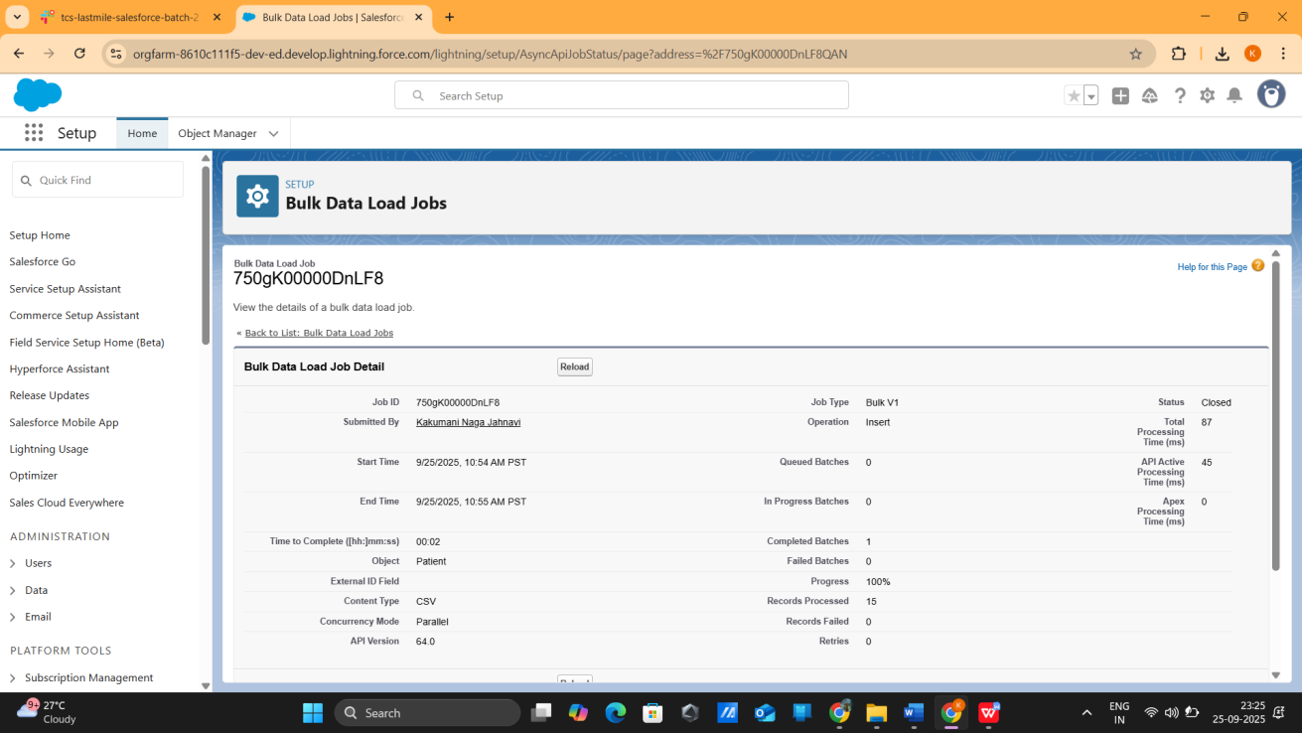

## ****Duplicate Management****

Duplicate Rules are implemented to prevent the creation of duplicate patient records. These rules compare critical fields such as email, phone number, and name before saving records. Alerts or automatic blocking mechanisms notify users or prevent duplicates, thereby maintaining clean, reliable, and accurate data across the CRM.

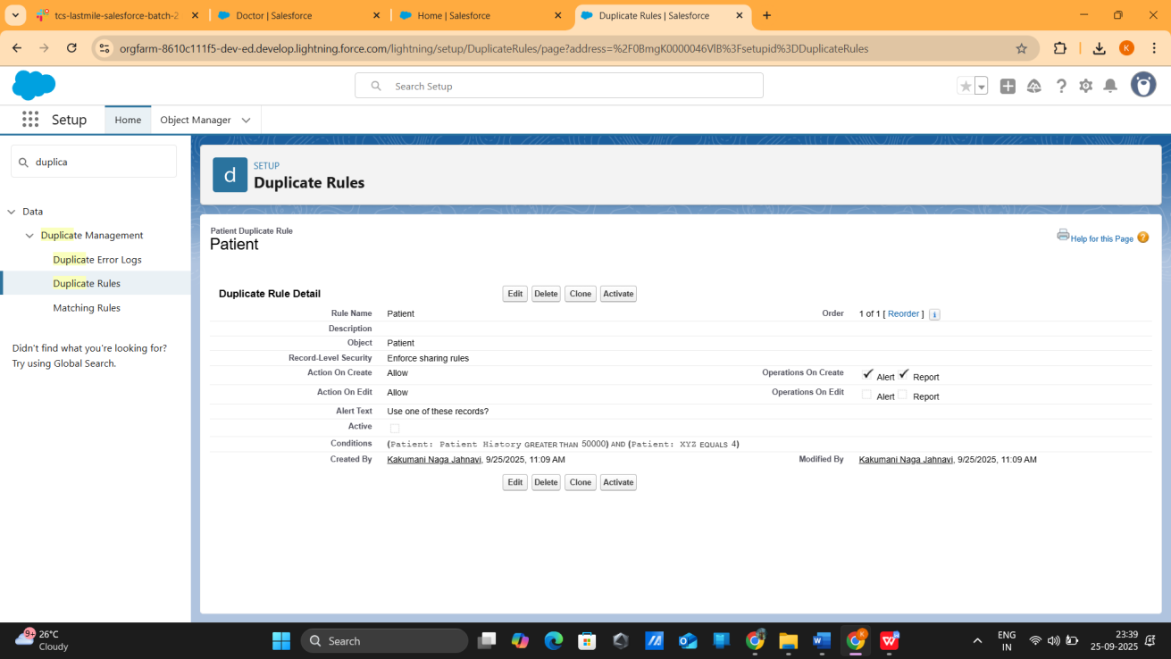

## ****Data Export & Backups****

Weekly data backups are scheduled using Salesforce’s **Data Export** functionality. Administrators can export objects and records into CSV files for storage. Regular backups ensure data security, provide historical records for audits, and support disaster recovery efforts.

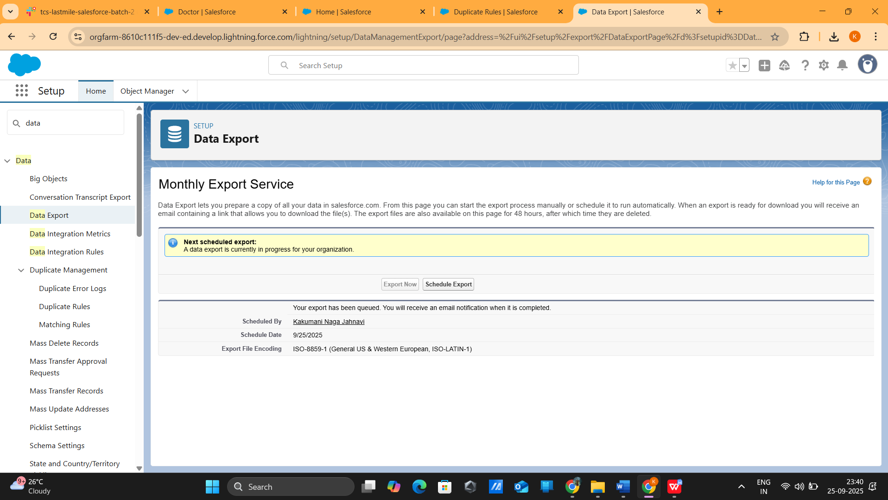

## ****Change Sets for Workflow and Flow Deployment****

Salesforce **Change Sets** are used to migrate workflows, flows, validation rules, and other declarative components from Sandbox to Production. Change Sets provide a controlled and secure way to deploy configurations while maintaining system integrity. Components are validated and deployed in a structured manner, ensuring consistency between environments.

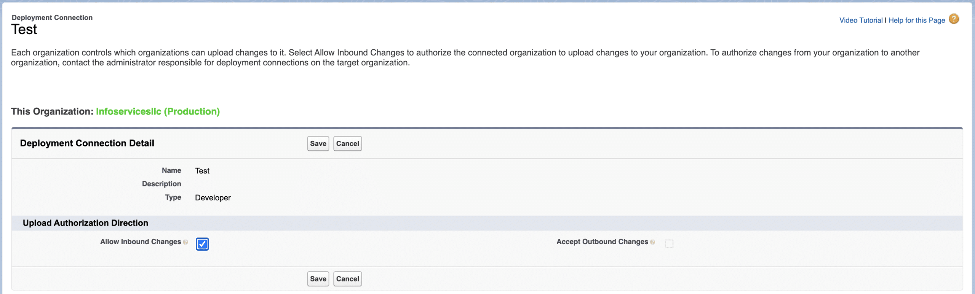

## ****VS Code + SFDX for Apex and LWC Deployment****

For custom development, including Apex classes and Lightning Web Components (LWC), Salesforce developers use **VS Code with Salesforce DX (SFDX)**. This setup supports source-driven development, version control, and easy deployment across environments. Developers can retrieve, modify, and deploy code efficiently while collaborating with team members.

